6. Transfer Data to G/L

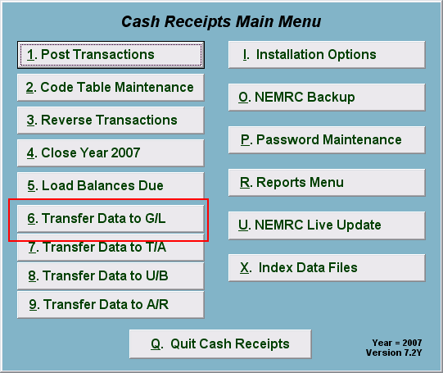
Click on “6. Transfer Data to G/L” from the Main Menu and the following window will appear:

Transfer Data to G/L

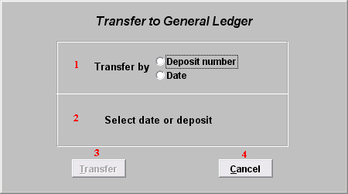
- Transfer by: Click on the circle next to Deposit number or Date, depending on how you wish to Transfer by. Best practice is to perform all work by deposit number.

- Select date or deposit: Enter the deposit number or date to transfer.

- Transfer: Click “Transfer” to transfer the data you specified to the General Ledger. A report will print out with the entries that are to be posted. Confirm the debit amount to the cash account is exactly what was taken to the bank.

- Cancel: Click “Cancel” to cancel and return to the previous screen.

